**NEW DISTRICT 8 AUXILIARY OFFICERS**

**PRESIDENT: LINDSAY BROWN**

**PROJECT: JAVELAN SERVICE DOGS**

I have been a member of the Gretna American Legion Auxiliary since September of 1983 and am now a PUFL member. I am eligible to be a member through my Grandfather Leonard Koch who fought in WWII. My family is highly involved in the legion. Most will know my Mom Kathy Mazur who has many titles, Past District President, Sarpy County Vice President, Past Department President, Past NEC and Past Chairmanships at department and national level. Being District President I do have a lot of fundraiser I would like to get moving on to raise money for not only my project but other projects as well, so please get ready to reply on votes.

**Vice President: Vacant**

**Security/Treasurer: Kathy Mazur PUFL member Gretna Unit 216**

**Chaplain: Becky Saathoff PUFL member Papillion unit 32**

**NOTE:**

I look forward to getting to all your unit meetings and possibly some of your events and meeting as many as you as possible. I would appreciate if all Units can please send me when your meeting are held so I can start getting them on my calendar. I would also like a list of events your unit will be holding so I can put them on not just my calendar to try to attend but also to send to the rest of our district family and department family. If you have any question please don’t hesitate to contact me:

Lindsay Brown

20 S 41st Street Apt 111

Council Bluffs, IA 51501

402-578-9222

NEDistrict8ALA@gmail.com

**Recent Events**

*Department President Vicki Ozenbaugh presenting Cindy Moore President of Gretna Unit 216 with the Unit Member of the year award.*

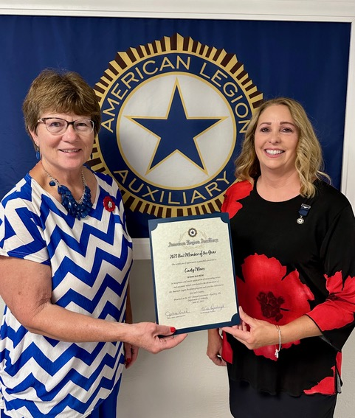

**EVENTS CALENDAR**

**National Convention:**  August 26-31st.

**Fall Round up:** October 15th - Gretna 1pm (For all members)

**Sarpy County Convention** TBD – Gretna

**Washington County Convention:** TBD

**Douglas County Convention** TBD

**District 8 Convention:** February 10th - Valley 9am (for all members)

**Department Homecoming and Auxiliary 101 -** Suppose to be sept 16 but still negotiating. (for all members)

**MEMBERSHIP**

***Department is now accepting 2023/2024 membership dues.***

**DEPARTMENT OF NEBRASKA**

**UNITS AT 100% & GREATER GOAL**

**WEDNESDAY – JULY 19, 2023**

**DISTRICT 8 -** 0216 GRETNA​​​103.03%

|  |  |  |  |  |  |  |  |  |  |  |
| --- | --- | --- | --- | --- | --- | --- | --- | --- | --- | --- |
| **2023 Weekly Membership** | | | | | | | | | | |
| **Wednesday, July 19, 2023** | | | | | | | | | | |
| Department President Vicki Ozenbaugh | | | | | | | | | | |
| **DIST** | **DIST** | **DISTRICT** | **2023** | 2023 SR | 2023 JR | | 2023 | | PERCENT | |
| **Place** | **#** | **PRESIDENT** | **GOAL** | Paid | Paid | | Members | | % | |
| ***1st*** | **4** | Luayne Weisgerber | 672 | 573 | 77 | | 650 | | **96.73%** | |
| ***2nd*** | **12** | Charlene Hobelman | 1310 | 1133 | 89 | | 1222 | | **93.28%** | |
| ***3rd*** | **11** | Vicky Thompson | 2226 | 1777 | 293 | | 2070 | | **92.99%** | |
| ***4th*** | **9** | Maria Atterberry | 584 | 464 | 67 | | 531 | | **90.92%** | |
| ***5th*** | **2** | Carolyn Conroy | 1800 | 1450 | 185 | | 1635 | | **90.83%** | |
| ***6th*** | **13** | Anita Lang | 670 | 519 | 88 | | 607 | | **90.60%** | |
| ***7th*** | **1** | Mary Krause | 1282 | 1018 | 134 | | 1152 | | **89.86%** | |
| ***8th*** | **7** | Nancy Niemann | 1753 | 1400 | 164 | | 1564 | | **89.22%** | |
| ***9th*** | **3** | Beverly Neel | 905 | 711 | 82 | | 793 | | **87.62%** | |
| ***10th*** | **6** | Nancy Harrold | 2309 | 1820 | 202 | | 2022 | | **87.57%** | |
| ***11th*** | **5** | Donna Hatfield | 712 | 564 | 55 | | 619 | | **86.94%** | |
| ***12th*** | **8** | Paula Pillen | 1599 | 1235 | 134 | | 1369 | | **85.62%** | |
| ***13th*** | **10** | Cathy Webber | 1040 | 760 | 81 | | 841 | | **80.87%** | |
|  | **DEPT. 500** | | **229** |  | Dept 500 | | 101 | | **44.10%** | |
|  |  |  |  |  |  | | |  | |  | |  |
| **2023** | **DEPARTMENT GOAL** | | **17091** | **13521** | **1655** | | **15176** | | **88.80%** | |  |  |
|  |  |  |  |  |  | | |  | |  | |  |
|  | **Veterans - Our Soul and Inspiration - Beverly Neel - 2022-2023** | | | |  |  |  |  |  |  |  |  |
|  |  |  |  |  |  | | |  | |  | |  |  |  |  |  |

**Mid year Conference -** January 12-14 Ramada Kearney

**Mission training and Junior Meeting.**                         February 3, 2024 at Cornhusker Marriott Lincoln  (for all members must register)

**Veterans Dollar Days.** Monday November 6th. 10am Omaha VA Medical. 2pm Eastern Nebraska Vets Home

**Stand Down Omaha.**  Friday November 17th.

9am-4pm UNO Milo

**Veterans Gift Shop Set up.**

Monday December 4.

10am-230pm medical center

**Veterans Gift Shop**

December 5-7 Shopping & Gift Wrapping

**Gift for Yanks**

Monday December 11.

10am Omaha VA Medical

2pm Eastern Nebraska Veterans Home

**Creative Arts Festival Omaha**

**Deadline**

April 23, 2024

**New Dept Officers**

President: Lisa Moore

Vice President: Amanda Washburn