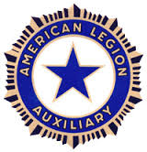
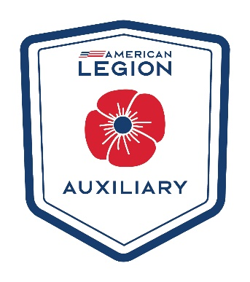
American Legion Auxiliary
District 11 Newsletter
July 2025

Meet the President:
I just wanted to introduce myself to those of you who do not know me. I’m Mary Beth Coffey from Mc Cool Junction. I have resided here for the majority of my life. My husband Albert is a native of Exeter, NE. We have 6 children and 10 grandchildren.
How did I get started in the American Legion Auxiliary? My father Robert E Smith was a WWII Veteran. He was stationed in England with the Army Air Corps with the 108th Airborne Division. He was on a bomber crew named the Lutes Crew. He was very active in and proud to be in the Legion and the Drum & Bugle Corps. I learned my patriotism and love of my country through him. I was a Junior Auxiliary member back in the late 70’s early 80’s. I got married early and started having children. I didn’t start back up into the Unit until the late 90’s early 2000’s. I really didn’t start getting involved until my 2 sons joined the National Guard and Reserves and went to Iraq in 2005. They both served 18 months in Iraq at mostly the same time. My son Jim served that once and my other son Rob has served 2 other times in Kuwait.
I have been our Unit 341 President for last 10 years. I was York County President from 2022-2024.
It is my honor to serve as the District 11 President. It is my hope that I will serve you well and be a president you can be proud of. Please always feel free to contact me if you need something. I might not know the answer, but I can help you find it.
My theme for this year is along with our Legion’s “Be The One” initiative. My focus is on our Veteran’s PTSD and mental health issue.
Let’s BUILD each other!
B – Be the One!
U – Unite and help each other achieve our goals!
I – Inspire and motivate one another!
L – Listen to each other!
D – Dedicate ourselves to helping each other!
I am still trying to figure out what I’m doing for my project but it will be along this line. I am currently looking to find a place that helps get Veterans Service dogs. If anyone has any suggestions or knows of somewhere that serves our District, I would love to find out about it.
Mary Beth Coffey
District 11 President
209 Road M
McCool Junction, NE 68401
402-366-3207
mbc.dist11pres25@gmail.com
Department Convention:
The Department Convention was held in Columbus, NE on June 27th - 29th
Well, as a newbie I really didn’t know what to expect but I will tell you that this weekend exceeded my expectations and I learned a lot!
Meet your Newly Elected Department Officers
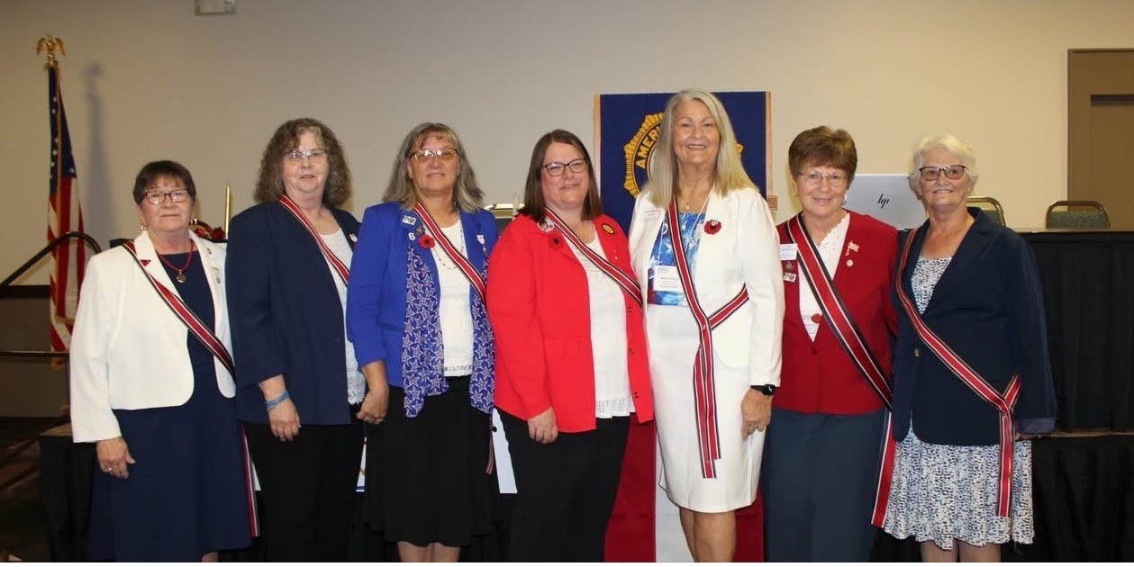

From left to right: Roxanne Hiatt, Department Secretary; Vicki Colson, Department Chaplain,
Lori Riemers, Department Historian; Vicki Cyboron, Department Vice President;
Ruth Hietbrink, Department President; Vicki Ozenbaugh, National Executive Committee member;
and Jacki O’Neill, Department Treasurer.

President Ruth’s theme this year is “Stirring UP Members” Her project for the year is the building the Auxiliary Emergency Fund (AEF).
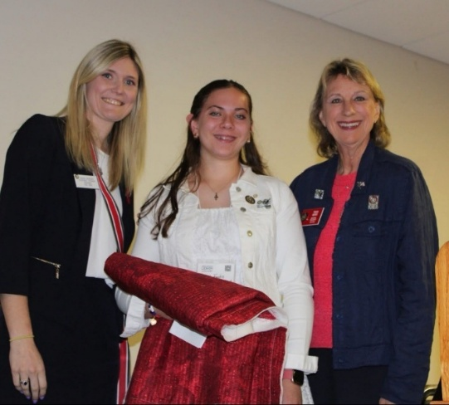

Past President 24-25 Amanda Washburn,
Junior President Erica Fuchs,
National President Trish Ward
Our Junior President this year is Erica Fuchs from Arlington, NE.
Our National President Trish Ward was here this year and very passionate about membership and helping other Units if they are struggling to keep their Charter. We have lost 2200 Charters nationwide this past year!

2025-2026 SLATE OF APPOINTED POSITIONS

AMERICANISM Cie Kauth NATIONAL SECURITY Amanda Washburn
AEF Vicki Ozenbaugh PARLIAMENTARIAN Lynne Wild
CHILDREN/YOUTH Julie Schnitzler PAST PRES’S PARLEY Lisa Moore
COMMUNITY SVC Nancy Niemann POPPY Justina Birkel
C/B/S Gayla Schmid PUBLIC RELATIONS Meri Hietbrink
CO GOVERNMENT Gayla Schmid THE STAR – EDITOR Lorene Bartos
EDUCATION Cindy Moore SERVICE TO VET’S Maria Atterberry
FINANCE Karen Brink VET’S AFFAIRS & REHAB Amanda Washburn
GIRLS STATE CHIARMAN Vicki Ozenbaugh GRAND ISLAND VAMC REP. Vicki Cyboron
1ST VICE CHAIR Vicki Colson VAMC DEPUTY Carmen Larson
2ND VICE CHAIR Elsa Knight VAMC DEPUTY Nancy Griffiths
SECRETARY Kathy Mazur OMAHA VAMC REP. Paula Pillen
ADVISORY – 5TH YEAR TBA OMAH VAMC DEPUTY TBA
JR ACTIVITIES TBA CNVH CHAIRMAN Kathy Fisher
LEADERSHIP Tina Nelson ENVH CHAIRMAN Donna Smith
LEGISLATIVE Loree Hendrickson NVH CHAIRMAN LaRee Kubes
MEMBERSHIP Deb Albers WNVH CHAIRMAN Cecil Doshier
MUSIC Jean Vackiner
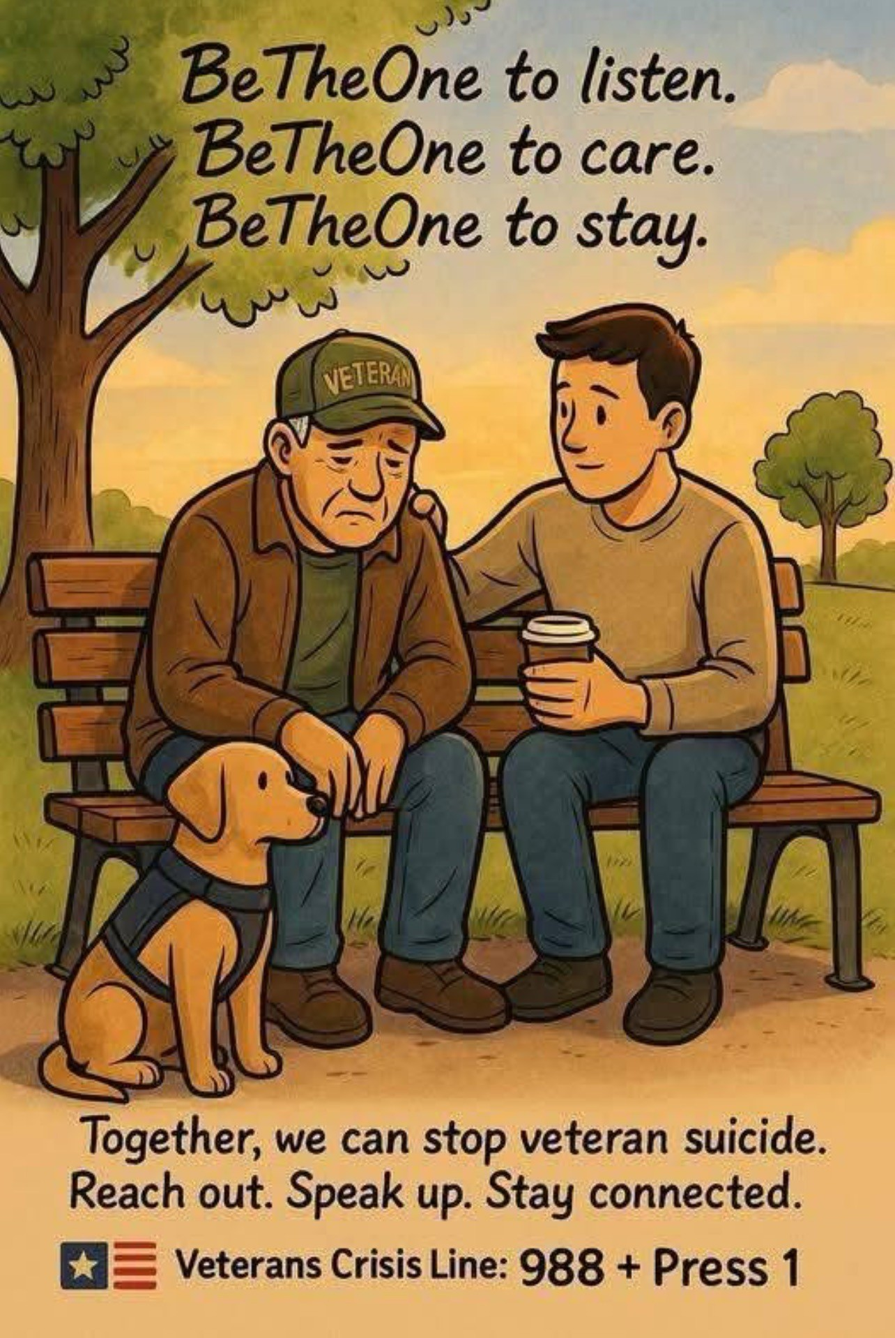
DISTRICT PRESIDENTS
ONE Jean Vackiner
TWO Corrine Janovec
THREE Laura Novak
FOUR Terri Poley
FIVE Eva Crawford
SIX Barb Dorsey
SEVEN Nancy Patras
EIGHT Lea Brauer
NINE Lana Bennett
TEN Deanna Tuttle
ELEVEN Mary Beth Coffey
TWELVE Erma Naber
THIRTEEN Bobbie Albers
Important Dates:
National Convention is August 22th – 28th in Tampa, Florida
Veterans Day at the State Fair - Date: Monday, September 1st, 2025.
- Event: A Veterans Day program will be held at the Heartland Events Center.
- Time: The program begins at 10:30 AM.
- Activities: The program will include a POW/MIA empty chair recognition, a moment of silence for fallen veterans, a flag history ceremony, a keynote speaker, and special recognition of the armed forces.
- Other Recognition: Veterans and active-duty military personnel will receive free admission to the State Fair with proper ID.
Commander Judy Walter’s Homecoming – September 13th in Ainsworth, NE
President Ruth’s Leadership Training & Homecoming – September 27th in Bennet, NE at
the Legion Hall at 2:00 pm. More information will be in The Star so keep watch. You
will need to RSVP to the Department.

I still need to fill some positions for my Officers and Chairman. If any of you could please step up and help me, I would be very grateful. Here’s what we have so far and what I still need:

President – Mary Beth Coffey
Vice President – Karen White
Secretary/Treasurer – Vicky Fleming
Parliamentarian – Deb Albers
Chaplain –
Historian –
Music Chair –
Poppy Chair – I think I have this one filled.
Immediate Past President – Cindy Summers Lugan

Constitution, Bylaws, Standing Rules Committee: Seat 1-5

Please, if I asked anyone to do anything and you told me yes and I don’t have you down, it’s because my mind was reeling at District convention after election and I’m not sure what and who I asked to do what. Please just let me know.

I do have to have a Zoom DEC meeting to get the flags ordered as soon as possible. So, I would love to get these positions filled so we can have as many votes as possible.

Ready, Set Go for Dues this year!!
Secretary Roxanne said she can start taking them at any time now! New Auxiliary members that are just joining can’t be added until after September 1st. She also has a challenge to the 1st District to reach 100% membership by Aug. 20th (her birthday), she will personally pay for the hotel room for up to 3 nights at the Department Convention!
Let’s go for 2 years in a row for District 11 to get to #1 for getting Dues in!!
Deadline for getting Dues awards! Let’s help get those Dues in early! See attached for the Awards!

2026 Membership Awards

Member Award: Recruit/Rejoin l0
- Award: Special gift selected by the National Membership Chairman
- Presented to: Members who recruit and/or rejoin 10 Senior and/or Junior members. Rejoined
members must not have renewed since 2022 or earlier.
- Deadline: Members must be entered and paid in ALAMIS member database by June 1,2026.
- FORMS must be received at National HQ by June 6. 2026.
- Materials and guidelines:
  - Forms can be printed from the ALA national Membership Committee page of the national
website (www.AlAforVeterans.org). You must be logged in to the My Auxiliary area to
access the page.
  - One entry per recruiter.

Member Award: Family 3
- Award: Special gift selected by the National President
- Presented to: Members who recruit 3 New Legion members, 3 New Auxiliary members & 3 New
SAL members.
- Deadline: Members must be entered and paid for in the database by June 1,2026.
- FORMS must be received at ALA National HQ by June 6,2026
- Materials and guidelines:
  - Forms can be printed from the ALA national Membership Committee page of the national
website (www.AlAforVeterans.ore). You must be logged in to the My Auxiliary area to
access the page.
  - One entry per recruiter.

Unit Award: 100%o Unit Award
- Award: ALA Key Chain with phone stand and cleaner, 2 per unit for the unit president and unit
membership chairman.
- Presented to: Units that reach 100% of their 2026 membership goal by January 31,2026.
- Deadline: January 31,2026
- Materials and guidelines:
  - This award will be based on units that reach 100% of their reported goals by January 31, 2026, as verified by ALAMIS.
Note: Departments must submit unit goals to National Headquarters by September 1, 2025 to be eligible for the l00% Unit Award. These must be sent in a specific format which will be provided by NHQ. Key chains for winning units will be mailed to each department for distribution.

Department Membership Goals: Department membership goals are based on each department’s 2024 membership as of 12/31/2024 plus a percentage increase chosen by each department during the 2025 Department Leadership National Conference.

Department Awards Deadlines:
- 25% Department Award Deadline – SAL Birthday, September 15, 2025
  - Award: $25
- 60% Department Award Deadline – ALA Birthday, November 10, 2025
  - Award: $60
- 85% Department Award Deadline – TAL Birthday, March 15, 2026
  - Award: $85
- 95% Department Award Deadline – Female Veterans Day, Jun 12, 2026
  - Award: $95
- 100% Department Award Deadline – Independence Day, July 4, 2026
  - Award: $250
- 102% Department Award Deadline – 30 Prior to National Convention, August 1, 2026
  - Award: $500
- 95% Retention Award – any department that reaches 95% retention rate by August 1,
2026.
  - Award: Citation Plaque
Seating at National Convention: Seating at National Convention will be based on each department’s percentage of their 2026 membership goal, from highest to lowest.

