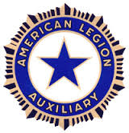
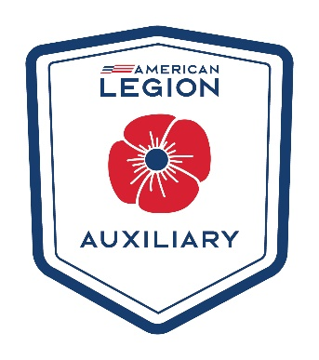
American Legion Auxiliary
District 11 Newsletter
August 2025

New News:
My theme for this year is along with our Legion’s “Be The One” initiative. My focus is on our Veteran’s PTSD and mental health issues.
Let’s BUILD each other!
B – Be the One!
U – Unite and help each other achieve our goals!
I – Inspire and motivate one another!
L – Listen to each other!
D – Dedicate ourselves to helping each other!
My project for this year is to raise money for a program named JAVELAN.
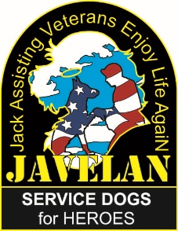
This program was started by Robert Dean. His wife is a Veteran and needed a service dog and they personally seen how important these dogs are, so they decided to try to do a program to help others. How this program works is when a Veteran (or First Responder) would like a service dog they need to contact them and the only cost to the Veteran (or First Responder) is $25. If the Veteran has a dog that is 3 years or younger they will come out and train their dog that they currently have. If they don’t have a dog, then the JAVELAN program will get a dog through Pet for Vets (another rescue program for Veterans) or the local Humane Society. If the Veteran wants a specific kind of dog, they need to acquire that on their own. The Trainer comes to the Veteran and will train the dog at the expense of the JAVELAN program. This program is nonprofit and relies solely on donations. When I spoke with Mr. Dean he told me that if anyone would like him to come to their meetings and would like more information he would be glad to do so.
Here are a few links to videos that help explain his program
https://www.facebook.com/javelanforvets/videos/2837914459678761/
https://www.facebook.com/javelanforvets/videos/740745814241781/
https://www.facebook.com/javelanforvets/videos/24278579075071592/

I will be raffling off a couple things to make money for a donation to this program. The 1st prize is an Eagle lawn Decoration and a Patriotic picture of bird houses and cardinals. The 2nd Prize is a Patriotic picture of dogs in the back of an old pickup and flag and a patriotic table centerpiece.
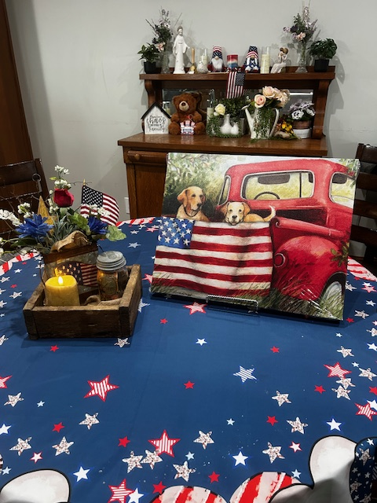
2nd Prize
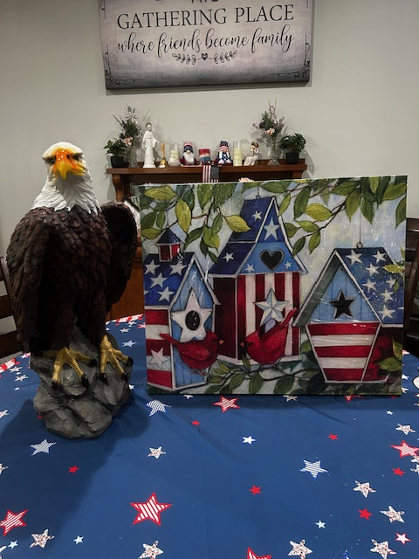
1st Prize

Important Dates:
National Convention is August 22th – 28th in Tampa, Florida
Veterans Day at the State Fair - Date: Monday, September 1st, 2025.
- Event: A Veterans Day program will be held at the Heartland Events Center.
- Time: The program begins at 10:30 AM.
- Activities: The program will include a POW/MIA empty chair recognition, a moment of silence for fallen veterans, a flag history ceremony, a keynote speaker, and special recognition of the armed forces.
- Other Recognition: Veterans and active-duty military personnel will receive free admission to the State Fair with proper ID.
- Parade – will start Sept 1st at 1pm
Commander Judy Walter’s Homecoming – September 13th in Ainsworth, NE
President Ruth’s Leadership Training & Homecoming – September 27th in Bennet, NE at
the Legion Hall at 2:00 pm. More information will be in The Star so keep watch. You
will need to RSVP to the Department.
Fall Round Up - is in Friend on September 20th at 2:00pm. Robert Dean from the JAVELAN program
has agreed to speak and let us know more about the JAVELAN program.
District 11 Convention – will be March 21st in Beatrice beginning @ 10am

I have filled my Officer positions. Thank you everyone

President – Mary Beth Coffey
Vice President – Karen White
Secretary/Treasurer – Vicky Fleming
Parliamentarian – Deb Albers
Chaplain – Donna Schweer
Historian – Cindy Summers Lugan
Music Chair – Julia Pohlmann
Poppy Chair – Marilyn White
Immediate Past President – Cindy Summers Lugan

New Flags:

I would like to have a DEC meeting on Sept 20th before Fall Roundup at 12 pm so we don’t have to have another day to travel. We need to decide on our Flags as soon as possible. Vicki Flemming’s daughter has an American Flag (which is exactly like the flag we would be ordering and in good shape) that she would like to donate to us. Vicki has agreed to bring it to our meeting so we can look at it and decide if that flag is what we want to keep and save some money. We have $1,250 currently for the purchase of the new flag and we need $1,882.9 plus shipping & handling for the purchase. So, we are still a little short. We still need $632.9 plus shipping and handling so if your Unit or County has not donated yet could you please consider it and this would be much appreciated. If you would like to bring the donations to Fall Roundup that would be great!

Ready, Set Go for Dues this year!!
Secretary Roxanne said she can start taking them at any time now for all members. She also has a challenge to the first District to reach 100% membership by Aug. 20th (her birthday), she will personally pay for the hotel room for up to 3 nights at the Department Convention!
Let’s go for 2 years in a row for District 11 to get to #1 for getting Dues in!!
Deadline for getting Dues awards! Let’s help get those Dues in early! See attached for the Awards!

FYI:

The membership goals list that was provided in our Membership Packets was incorrect. A Corrected version will be made available via the next Headquarters Newsletter (coming out before the National Convention).

2026 Membership Awards

Member Award: Recruit/Rejoin l0
- Award: Special gift selected by the National Membership Chairman
- Presented to: Members who recruit and/or rejoin 10 Senior and/or Junior members. Rejoined
members must not have renewed since 2022 or earlier.
- Deadline: Members must be entered and paid in ALAMIS member database by June 1,2026.
- FORMS must be received at National HQ by June 6. 2026.
- Materials and guidelines:
  - Forms can be printed from the ALA national Membership Committee page of the national
website (www.AlAforVeterans.org). You must be logged in to the My Auxiliary area to
access the page.
  - One entry per recruiter.
Member Award: Family 3
- Award: Special gift selected by the National President
- Presented to: Members who recruit 3 New Legion members, 3 New Auxiliary members & 3 New
SAL members.
- Deadline: Members must be entered and paid for in the database by June 1,2026.
- FORMS must be received at ALA National HQ by June 6,2026
- Materials and guidelines:
  - Forms can be printed from the ALA national Membership Committee page of the national
website (www.AlAforVeterans.ore). You must be logged in to the My Auxiliary area to
access the page.
  - One entry per recruiter.

Unit Award: 100% Unit Award
- Award: ALA Key Chain with phone stand and cleaner, 2 per unit for the unit president and unit
membership chairman.
- Presented to: Units that reach 100% of their 2026 membership goal by January 31,2026.
- Deadline: January 31,2026
- Materials and guidelines:
  - This award will be based on units that reach 100% of their reported goals by January 31, 2026, as verified by ALAMIS.
Note: Departments must submit unit goals to National Headquarters by September 1, 2025, to be eligible for the l00% Unit Award. These must be sent in a specific format which will be provided by NHQ. Key chains for winning units will be mailed to each department for distribution.

Thank you everyone for all your help getting this new year started. I hope to see you all soon!

Mary Beth Coffey
District 11 President
209 Road M
McCool Junction, NE 68401
402-366-3207
mbc.dist11pres25@gmail.com

